In this project, I used the DataBaseFirst approach.

All sql scripts are in the root of the project.

Since the task is not big, I provided only 4 tables in the database.

Below is a screenshot.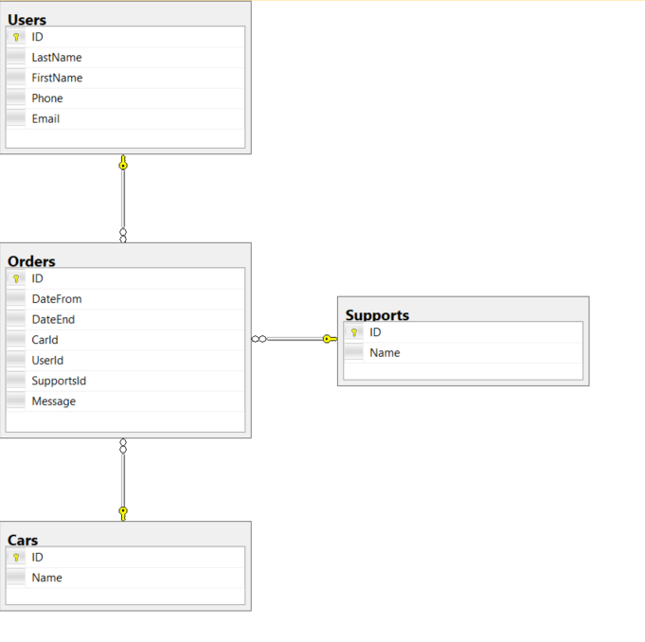

By architecture.

There are 4 projects in the solution.

- DAL level with context and models, which interacts with the database through repositories

- BLL level with business logic

- API it accepts requests that come from the UI and sends them to the services at the BLL level for further processing

- as well as the level of UI. Here, to reflect the calendar, I connected ngx-bootstrap.  
  
On the UI, I implemented one service that sends requests to the backend. But ideally, I would make separate services to interact with individual controllers.  
  
I want to say the same about backing part.

There is one basic repository, IBaseRepository, which contains common methods for implementation and small separate repositories with specific methods for working with data.

The same applies to the level of business logic.

I tried to abstract so as not to complicate the understanding of what is happening.